Operations Management, 10e, Global Edition (Heizer/Render)
Chapter 8 Location Strategies

1) FedEx chose Memphis, Tennessee, for its central location, or "hub," primarily because of the incentives offered by the city of Memphis and the state of Tennessee.
Answer: FALSE
Diff: 1
Topic: Global company profile
Objective: no LO

2) Generally, the objective of the location decision is to maximize the firm's profit.
Answer: FALSE
Diff: 1
Topic: The strategic importance of location
Objective: LO8-1

3) Lists have been developed that rank countries on issues such as "competitiveness" and "corruption."
Answer: TRUE
Diff: 1
Topic: Factors that affect location decisions
Objective: LO8-1

4) When innovation replaces cost as a firm's focus for location decisions, the presence of other state-of-the-art firms is a plus, not a negative, for the firm's competitiveness.
Answer: TRUE
Diff: 2
Topic: The strategic importance of location
Objective: LO8-1

5) The ratio of labor cost per day to productivity, in units per day, is the labor cost per unit.
Answer: TRUE
Diff: 2
Topic: Factors that affect location decisions
Objective: LO8-1

6) For a location decision, labor productivity may be important in isolation, but low wage rates are a more important criterion.
Answer: FALSE
Diff: 2
Topic: Factors that affect location decisions
Objective: LO8-1

7) Unfavorable exchange rates can offset other savings in a location decision.
Answer: TRUE
Diff: 2
Topic: Factors that affect location decisions
Objective: LO8-1
8) An example of an intangible cost, as it relates to location decisions, is the quality of education.
Answer: TRUE
Diff: 2
Topic: Factors that affect location decisions
Objective: LO8-1

9) In location decisions, intangible costs are easier to measure than tangible costs.
Answer: FALSE
Diff: 2
Topic: Factors that affect location decisions
Objective: LO8-1

10) Location decisions are based on many things, including costs, revenues, incentives, attitudes, and intangibles, but not on ethical considerations.
Answer: FALSE
Diff: 1
Topic: Factors that affect location decisions
AACSB: Ethical Reasoning
Objective: LO8-1

11) Manufacturers may want to locate close to their customers, if the transportation of finished goods is expensive or difficult.
Answer: TRUE
Diff: 2
Topic: Factors that affect location decisions
Objective: LO8-1

12) One reason for a firm locating near its competitors is the presence of a major resource it needs.
Answer: TRUE
Diff: 2
Topic: Factors that affect location decisions
Objective: LO8-1

13) The graphic approach to location break-even analysis displays the range of volume over which each location is preferable.
Answer: TRUE
Diff: 2
Topic: Methods of evaluating location alternatives
Objective: LO8-4

14) The factor-rating method can consider both tangible and intangible costs.
Answer: TRUE
Diff: 2
Topic: Methods of evaluating location alternatives
Objective: LO8-3
15) The center-of-gravity method finds the location of a centralized facility, such as a distribution center, that will maximize the organization's revenue.
Answer: FALSE
Diff: 2
Topic: Methods of evaluating location alternatives
Objective: LO8-5

16) The transportation model calculates an optimal shipping system between a central facility and several outlying customers.
Answer: FALSE
Diff: 2
Topic: Methods of evaluating location alternatives
Objective: LO8-5

17) Service firms choose locations based, in part, on the revenue potential of a site.
Answer: TRUE
Diff: 2
Topic: Service location strategy
Objective: LO8-6

18) Starbucks Coffee's approach to choosing new café locations is largely based on executive intuition, not sophisticated models and site selection technology.
Answer: FALSE
Diff: 1
Topic: Service location strategy
Objective: LO8-6

19) Labor cost and labor availability often drive the location decision in the call center industry.
Answer: TRUE
Diff: 2
Topic: Service location strategy
Objective: LO8-6

20) The location decisions of goods-producing firms will generally pay more attention to parking, access, and traffic counts than will service location decisions.
Answer: FALSE
Diff: 2
Topic: Service location strategy
Objective: LO8-6

21) Industrial location decisions often assume that costs are relatively constant for a given area.
Answer: FALSE
Diff: 2
Topic: Service location strategy
Objective: LO8-6
22) Starbucks Coffee's use of geocoded demographic and consumer data in site selection decisions is an example of the use of a Geographic Information System, or GIS.
Answer: TRUE
Diff: 2
Topic: Service location strategy
Objective: LO8-6

23) FedEx chose Memphis, Tennessee, as its U.S. hub because
A) the city is in the center of the U.S., geographically
B) the airport has relatively few hours of bad weather closures
C) it needed a means to reach cities to which it did not have direct flights
D) the firm believed that a hub system was superior to traditional city-to-city flight scheduling
E) All of the above are true.
Answer: E
Diff: 1
Topic: Global company profile
Objective: no LO

24) Which of the following statements regarding FedEx is true?
A) Its hub in Memphis, Tennessee, was selected because of its low cost.
B) Memphis, Tennessee, is the only hub in the company's global flight network.
C) FedEx believes the hub system helps reduce mishandling and delays due to better controls.
D) FedEx uses a hub system in the U.S., but a city-to-city network in other countries.
E) Memphis is FedEx's only hub airport in the United States.
Answer: C
Diff: 1
Topic: Global company profile
Objective: no LO

25) Industrial location analysis typically attempts to
A) reduce costs
B) maximize sales
C) focus more on human resources
D) be environmentally friendly
E) none of the above
Answer: A
Diff: 1
Topic: Strategic importance of location
Objective: LO8-1
26) Transportation costs can account for as much as what % of a product's selling price?
A) 5%
B) 10%
C) 15%
D) 20%
E) 25%
Answer: E
Diff: 2
Topic: Strategic importance of location
Objective: LO8-1

27) Changing locations can alter total operating expenses by as much as what %?
A) 10%
B) 15-25%
C) 30-40%
D) 50%
E) 60% and above
Answer: D
Diff: 2
Topic: Strategic importance of location
Objective: LO8-1

28) Which of the following was not a factor in determining the location of Intel's Arizona plant?
A) skilled labor availability
B) U.S. laws to protect intellectual property
C) tax breaks from local and regional government
D) proximity to Intel's California headquarters
E) All of the above were key factors.
Answer: E
Diff: 2
Topic: Strategic importance of location
Objective: LO8-1

29) Which of the following is the correct DESCENDING order for country competitiveness, according to the text?
A) U.S., Israel, Italy, Mexico, Egypt
B) U.S., Israel, Mexico, Egypt, Italy
C) Israel, U.S., Italy, Mexico, Egypt
D) Israel, Italy, U.S., Egypt, Mexico
E) None of the above is the correct descending order.
Answer: E
Diff: 2
Topic: Factors that affect location decisions
Objective: LO8-1
30) __________ and __________ are to key country success factors as __________ and __________ are to key region success factors.
A) Cultural issues, location of markets; site size and cost, zoning restrictions
B) Exchange rates, labor availability; site size and cost, environmental impact
C) Labor cost, currency risk; land costs, proximity to customers
D) Land costs, proximity to customers; labor cost, air and rail systems
E) All of the above are accurate relationships.
Answer: C
Diff: 2
Topic: Factors that affect location decisions
Objective: LO8-1

31) Which of the following workers is the most productive?
A) $50 wages, 10 parts produced
B) $10 wages, 1 part produced
C) $30 wages, 5 parts produced
D) $100 wages, 21 parts produced
E) $500 wages, 100 parts produced
Answer: D
Diff: 2
Topic: Factors that affect location decisions- labor productivity
AACSB: Analytic Skills
Objective: LO8-2

32) A employee produces 15 parts during a shift in which he made $90. The labor content of the product is
A) $90
B) $5
C) $6
D) $.167
E) none of the above
Answer: C
Diff: 2
Topic: Factors that affect location decisions- labor productivity
AACSB: Analytic Skills
Objective: LO8-2

33) Instead of comparing the salaries of Detroit autoworkers to foreign autoworkers to determine if Union labor prices are the cause of Detroit's financial woes, which of the following should be used?
A) labor content per vehicle
B) labor productivity
C) total production
D) A or B
E) None of the above, salary is the best comparison.
Answer: D
Diff: 2
Topic: Factors that affect location decisions- labor productivity
Objective: LO8-2
34) The reason fast food restaurants often are found in close proximity to each other is
A) they enjoy competition
B) location Clustering near high traffic flows
C) low cost
D) availability of skilled labor
E) all of the above
Answer: B
Diff: 2
Topic: Factors that affect location decisions
Objective: LO8-1

35) While Volkswagen uses __________ to evaluate location alternatives, a local grocery chain would rather use __________ to determine where to locate its distribution center.
A) transportation model, center-of-gravity
B) transportation model, factor rating
C) break-even analysis, center-of-gravity
D) break-even analysis, transportation model
E) center-of-gravity, transportational model
Answer: A
Diff: 2
Topic: Methods of evaluating location alternatives
Objective: LO8-5

36) Governmental attitudes toward issues such as private property, intellectual property, zoning, pollution, and employment stability may change over time. The term associated with this phenomenon is
A) bureaucratic risk
B) political risk
C) legislative risk
D) judicial risk
E) democratic risk
Answer: B
Diff: 2
Topic: Factors that affect location decisions
Objective: LO8-1

37) A location decision for an appliance manufacturer would tend to have a(n)
A) cost focus
B) labor focus
C) revenue focus
D) environmental focus
E) education focus
Answer: A
Diff: 2
Topic: Strategic importance of location
Objective: LO8-1
38) A location decision for a traditional department store (Macy's) would tend to have a(n)
A) cost focus
B) labor focus
C) revenue focus
D) environmental focus
E) education focus
Answer: C
Diff: 2
Topic: Strategic importance of location
Objective: LO8-1

39) Globalization of the location decision is the result of all of the following except
A) market economics
B) higher quality of labor overseas
C) ease of capital flow between countries
D) high differences in labor costs
E) more rapid, reliable travel and shipping
Answer: B
Diff: 2
Topic: Factors that affect location decisions
AACSB: Multicultural and Diversity
Objective: LO8-1

40) In location planning, environmental regulations, cost and availability of utilities, and taxes are
A) global factors
B) country factors
C) regional/community factors
D) site-related factors
E) none of the above
Answer: C
Diff: 2
Topic: Factors that affect location decisions
Objective: LO8-1

41) A manufacturing firm finds a location that has a significant cost advantage over alternatives, but rejects that location because the educational infrastructure was insufficient to train the firm's workers in its special production technologies. The firm's action illustrates the link between __________ and location.
A) innovation
B) clustering
C) tax incentives
D) globalization
E) proximity
Answer: A
Diff: 1
Topic: The strategic importance of location
Objective: LO8-1
42) Which of the following is usually not one of the top considerations in choosing a country for a facility location?
A) availability of labor and labor productivity
B) exchange rates
C) attitude of governmental units
D) zoning regulations
E) location of markets
Answer: D
Diff: 2
Topic: Factors that affect location decisions
AACSB: Multicultural and Diversity
Objective: LO8-1

43) When making a location decision at the country level, which of these would be considered?
A) corporate desires
B) land/construction costs
C) air, rail, highway, waterway systems
D) zoning restrictions
E) location of markets
Answer: E
Diff: 2
Topic: Factors that affect location decisions
AACSB: Multicultural and Diversity
Objective: LO8-1

44) Which of these factors would be considered when making a location decision at the region/community level?
A) government rules, attitudes, stability, incentives
B) cultural and economic issues
C) zoning restrictions
D) environmental impact issues
E) proximity to raw materials and customers
Answer: E
Diff: 2
Topic: Factors that affect location decisions
Objective: LO8-1

45) When making a location decision at the region/community level, which of these would be considered?
A) government rules, attitudes, stability, incentives
B) cultural and economic issues
C) cost and availability of utilities
D) zoning restrictions
E) air, rail, highway, waterway systems
Answer: C
Diff: 2
Topic: Factors that affect location decisions
Objective: LO8-1
46) Which of these factors would be considered when making a location decision at the site level?
A) government rules, attitudes, stability, incentives
B) cultural and economic issues
C) zoning regulations
D) cost and availability of utilities
E) proximity to raw materials and customers
Answer: C
Diff: 2
Topic: Factors that affect location decisions
Objective: LO8-1

47) Tangible costs include which of the following?
A) climatic conditions
B) availability of public transportation
C) taxes
D) quality and attitude of prospective employees
E) zoning regulations
Answer: C
Diff: 2
Topic: Factors that affect location decisions
Objective: LO8-1

48) Intangible costs include which of the following?
A) quality of prospective employees
B) quality of education
C) availability of public transportation
D) all of the above
E) none of the above
Answer: D
Diff: 2
Topic: Factors that affect location decisions
Objective: LO8-1

49) Operations managers will need to consider ethical and social responsibility issues when location decisions involve
A) child labor issues
B) sweatshop conditions
C) allegiance to the firm's current location
D) corruption
E) all of the above
Answer: E
Diff: 2
Topic: Factors that affect location decisions
AACSB: Ethical Reasoning
Objective: LO8-1
50) A firm is seeking a new factory location, and is considering several countries worldwide. In some of these countries, child labor is prevalent; in others, working conditions and worker safety are inferior to conditions in the U.S. An operations manager paying attention to __________ will factor these issues into the location decision.
A) ethical and social responsibility issues
B) key success factors
C) factor-rating systems
D) geographic information systems
E) regression models
Answer: A
Diff: 1
Topic: Factors that affect location decisions
AACSB: Ethical Reasoning
Objective: LO8-1

51) Which of the following statements regarding "proximity" in the location decision is false?
A) Service organizations find that proximity to market is the most critical primary location factor.
B) Manufacturers want to be near customers when their product is bulky, heavy, or fragile.
C) Perishability of raw materials is a good reason for manufacturers to locate near the supplier, not the customer.
D) Reduction in bulk is a good reason for a manufacturer to locate near the supplier.
E) Clustering among fast food chains occurs because they need to be near their labor supply.
Answer: E
Diff: 1
Topic: Factors that affect location decisions
Objective: LO8-1

52) Which of the following is the best example of the proximity rule that, for service firms, proximity to market is the most important location factor?
A) Soft drinks are bottled in many local plants, where carbonated water is added to proprietary syrups that may have been shipped long distances.
B) Few people will travel out-of state for a haircut.
C) Patients will travel very long distances to have their hernia surgeries performed at Shouldice
Hospital.
D) Furniture makers choose to locate near the source of good hardwoods, even though it means locating near other furniture manufacturers.
E) Metal refiners (smelters) locate near mines to accomplish significant weight reduction near the metal's source.
Answer: B
Diff: 2
Topic: Factors that affect location decisions
Objective: LO8-1
53) Which of the following worker characteristics would likely be least important for U.S. firms looking to open up call centers in different countries?
A) willing to accept low wages
B) have a high level of education
C) speak English
D) possess an in-depth knowledge of American popular culture
E) are young
Answer: E
Diff: 2
Topic: Service location strategy
AACSB: Multicultural and Diversity
Objective: LO8-6

54) Community attitudes, zoning restrictions, and quality of labor force are likely to be considered in which of the following location decision methods?
A) transportation method
B) locational break-even analysis
C) center-of-gravity method
D) simulation
E) factor-rating method
Answer: E
Diff: 2
Topic: Methods of evaluating location alternatives
Objective: LO8-3

55) Which of the following methods best considers intangible costs related to a location decision?
A) crossover methods
B) locational break-even analysis
C) factor-rating analysis
D) the transportation method
E) the assignment method
Answer: C
Diff: 2
Topic: Methods of evaluating location alternatives
Objective: LO8-3

56) Evaluating location alternatives by comparing their composite (weighted-average) scores involves
A) factor-rating analysis
B) cost-volume analysis
C) transportation model analysis
D) linear regression analysis
E) crossover analysis
Answer: A
Diff: 2
Topic: Methods of evaluating location alternatives
Objective: LO8-3
57) A clothing chain is considering two different locations for a new retail outlet. They have identified the four factors listed in the following table as the basis for evaluation, and have assigned weights as shown on the left. The manager has rated each location on each factor, on a 100-point basis, as shown on the right.

Factor | Factor Description | Weight
1 | Average community income | .40
2 | Community growth potential | .25
3 | Availability of public transportation | .15
4 | Labor cost | .20

Barclay | Chester
30 | 20
40 | 30
20 | 20
10 | 30

What is the score for Chester?
A) 10.00
B) 24.50
C) 25.75
D) 27.00
E) 100.00
Answer: B
Diff: 2
Topic: Methods of evaluating location alternatives
AACSB: Analytic Skills
Objective: LO8-3

58) An approach to location analysis that includes both qualitative and quantitative considerations is
A) locational cost-volume
B) factor-rating
C) transportation model
D) assignment method
E) make or buy analysis
Answer: B
Diff: 2
Topic: Methods of evaluating location alternatives
Objective: LO8-3
59) On the crossover chart where the costs of two or more location alternatives have been plotted, the quantity at which two cost curves cross is the quantity at which
A) fixed costs are equal for two alternative locations
B) variable costs are equal for two alternative locations
C) total costs are equal for all alternative locations
D) fixed costs equal variable costs for one location
E) total costs are equal for two alternative locations
Answer: E
Diff: 2
Topic: Methods of evaluating location alternatives
Objective: LO8-4

60) A full-service restaurant is considering opening a new facility in a specific city. The table below shows its ratings of four factors at each of two potential sites.

Factor | Weight | Gary Mall | Belt Line
Affluence of local population | .20 | 30 | 30
Traffic flow | .40 | 50 | 20
Parking availability | .20 | 30 | 40
Growth potential | .20 | 10 | 30

The score for Gary Mall is __________ and the score for Belt Line is __________.
A) 120; 120
B) 22; 24
C) 18; 120
D) 34; 28
E) none of the above
Answer: D
Diff: 2
Topic: Methods of evaluating location alternatives
AACSB: Analytic Skills
Objective: LO8-3

61) A firm is considering two location alternatives. At location A, fixed costs would be $4,000,000 per year, and variable costs 0.30 per unit. At alternative B, fixed costs would be $3,600,000 per year, with variable costs of $0.35 per unit. If demand is expected to be 10 million units, which plant offers the lowest total cost?
A) Plant A, because it is cheaper than Plant B for all volumes under 8,000,000 units.
B) Plant B, because it is cheaper than Plant A for all volumes over 8,000,000 units.
C) Plant A, because it is cheaper than Plant B for all volumes.
D) Plant B, because it has the lower variable cost per unit.
E) Neither Plant A nor Plant B, because the crossover point is at 10 million units.
Answer: B
Diff: 1
Topic: Methods of evaluating location alternatives
AACSB: Analytic Skills
Objective: LO8-4
62) The center-of-gravity method does not take into consideration the
A) location of markets
B) volume of goods shipped to the markets
C) value of the goods shipped
D) combination of volume and distance
E) center-of-gravity method considers none of the above
Answer: C
Diff: 2
Topic: Methods of evaluating location alternatives
Objective: LO8-5

63) The center-of-gravity method is used primarily to determine what type of locations?
A) service locations
B) manufacturing locations
C) distribution center locations
D) supplier locations
E) call center locations
Answer: C
Diff: 2
Topic: Methods of evaluating location alternatives
Objective: LO8-5

64) A regional bookstore chain is about to build a distribution center that is centrally located for its eight retail outlets. It will most likely employ which of the following tools of analysis?
A) assembly line balancing
B) load-distance analysis
C) center-of-gravity model
D) linear programming
E) all of the above
Answer: C
Diff: 2
Topic: Methods of evaluating location alternatives
Objective: LO8-5
65) East Texas Seasonings is preparing to build one processing center to serve its four sources of seasonings. The four source locations are at coordinates shown below. Also, the volume from each source is provided. What is the center of gravity?

 | X-coordinate | Y-coordinate | Volume
Athens, Texas | 30 | 30 | 150
Beaumont, Texas | 20 | 10 | 350
Carthage, Texas | 10 | 70 | 100
Denton, Texas | 50 | 50 | 200

A) X = 28.125; Y = 31.25
B) X = 22000; Y = 24000
C) X = 27.5; Y = 40
D) center of gravity = 28
E) none of the above
Answer: A
Diff: 2
Topic: Methods of evaluating location alternatives
AACSB: Analytic Skills
Objective: LO8-5

66) A county wants to build one centrally-located processing facility to serve the county's four recycling drop-off locations. The four drop-offs have characteristics as given in the table below. What is the approximate center of gravity of these four locations?

Location | X-coordinate | Y-coordinate | Tonnage
Drop-off point A | 1 | 8 | 10
Drop-off point B | 6 | 7 | 35
Drop-off point C | 6 | 2 | 25
Drop-off point D | 4 | 7 | 50

A) 4.75, 6.04
B) 17, 24
C) 33.5, 135.4
D) 6, 4.25
E) 570, 725
Answer: A
Diff: 2
Topic: Methods of evaluating location alternatives
AACSB: Analytic Skills
Objective: LO8-5
67) Production and/or shipping costs are always considered in which of the following location decision methods?
A) factor-rating method
B) transportation method
C) locational break-even analysis
D) center-of-gravity method
E) crossover analysis
Answer: B
Diff: 2
Topic: Methods of evaluating location alternatives
Objective: LO8-5

68) The transportation method, when applied to location analysis
A) minimizes total fixed costs
B) minimizes total production and transportation costs
C) minimizes total transportation costs
D) maximizes revenues
E) minimizes the movement of goods
Answer: B
Diff: 2
Topic: Methods of evaluating location alternatives
Objective: LO8-5

69) Which of the following is not among the eight components of revenue and volume for a service firm?
A) quality of the management
B) shipment cost of finished goods
C) purchasing power of the customer-drawing area
D) uniqueness of the firm's and the competitor's locations
E) competition in the area
Answer: B
Diff: 2
Topic: Service location strategy
Objective: LO8-6

70) Which of the following is among the eight components of revenue and volume for a service firm?
A) uniqueness of the firm's and the competitor's locations
B) quality of the competition
C) quality of management
D) purchasing power of the customer-drawing area
E) all of the above
Answer: E
Diff: 2
Topic: Service location strategy
Objective: LO8-6
71) Traffic counts and purchasing power analysis of drawing area are techniques associated with
A) an industrial location decision
B) a manufacturing location decision
C) a retail or professional service location decision
D) the factor rating method
E) the transportation method
Answer: C
Diff: 2
Topic: Service location strategy
Objective: LO8-6

72) Which of the following statements regarding Starbucks Coffee is false?
A) The firm plans to open three new cafes per day around the world.
B) The firm uses GIS to evaluate every site decision.
C) The firm's cafes are exclusively in traditional settings: malls, tourist areas, and airports.
D) The firm places cafes into ever more innovative locations.
E) The firm put cafes in Japan, even though that country had no GIS data available.
Answer: C
Diff: 1
Topic: Methods of evaluating location decisions
Objective: LO8-1

73) LaQuinta Motor Inns has a competitive edge over its rivals because it
A) uses regression analysis to determine which variables most influence profitability
B) picks better locations than its rivals
C) picks larger locations than its rivals
D) builds only along interstate highways
E) all of the above
Answer: A
Diff: 2
Topic: Service location strategy
Objective: LO8-1

74) Traffic counts and demographic analysis of drawing areas are associated with
A) industrial location decisions
B) manufacturing location decisions
C) service location decisions
D) the transportation method
E) none of the above
Answer: C
Diff: 2
Topic: Service location strategy
Objective: LO8-1
75) What describes a system that stores and displays information that can be linked to a geographic location?
A) AIS
B) LOC
C) GLOC
D) LIS
E) GIS
Answer: E
Diff: 2
Topic: Service location strategy
AACSB: Use of IT
Objective: LO8-1

76) Location analysis techniques typically employed by service organizations include
A) factor rating method
B) center-of-gravity method
C) purchasing power analysis of area
D) traffic counts
E) all of the above
Answer: E
Diff: 2
Topic: Service location strategy
Objective: LO8-1

77) Which of the following is most likely to affect the location decision of a service firm rather than a manufacturing firm?
A) energy and utility costs
B) attitude toward unions
C) parking and access
D) cost of shipping finished goods
E) labor costs
Answer: C
Diff: 2
Topic: Service location strategy
Objective: LO8-1

78) Which of the following is a location analysis technique typically employed by a service organization?
A) purchasing power analysis
B) linear programming
C) queuing theory
D) crossover charts
E) cost-volume analysis
Answer: A
Diff: 2
Topic: Service location strategy
Objective: LO8-1
79) A jewelry store is more likely than a jewelry manufacturer to consider __________ in making a location decision.
A) transportation costs
B) cost of raw materials
C) parking and access
D) climate
E) taxes
Answer: C
Diff: 2
Topic: Service location strategy
Objective: LO8-1

80) Which of the following is a location analysis technique typically employed by a manufacturing organization?
A) transportation method
B) queuing theory
C) correlation analysis and traffic counts
D) simulation
E) demographic analysis
Answer: A
Diff: 2
Topic: Service location strategy
Objective: LO8-1

81) Which of these assumptions is not associated with strategies for goods-producing location decisions?
A) Most major costs can be identified explicitly for each site.
B) Focus on identifiable cost.
C) High customer contact issues are critical.
D) Intangible costs can be evaluated.
E) Location is a major determinant of cost.
Answer: C
Diff: 2
Topic: Service location strategy
Objective: LO8-1

82) Which of the following is most likely to affect the location strategy of a manufacturing firm?
A) appearance/image of the area
B) utility costs
C) purchasing power of drawing area
D) competition in the area
E) parking availability
Answer: B
Diff: 2
Topic: Service location strategy
Objective: LO8-1
83) Geographic Information Systems can assist the location decision by
A) automating center-of-gravity problems
B) computerizing factor rating analysis
C) combining geography with demographic analysis
D) updating transportation method solutions
E) giving good Internet placement for virtual storefronts
Answer: C
Diff: 2
Topic: Service location strategy
AACSB: Use of IT
Objective: LO8-1

84) FedEx schedules its aircraft using a __________ system, which it credits with reducing package mishandling and delay in transit.
Answer: central hub
Diff: 1
Topic: Global company profile
Objective: no LO

85) __________ costs are readily identifiable and can be measured with precision.
Answer: Tangible
Diff: 1
Topic: Factors that affect location decisions
Objective: LO8-1

86) When __________, in addition to creativity and R&D investments, is critical to operations strategy, cost may cease to be the primary focus of location criteria.
Answer: innovation
Diff: 1
Topic: The strategic importance of location
Objective: LO8-1

87) Political risk, cultural issues, and exchange rates are among those __________ that affect which country will be selected for a location decision.
Answer: Key Success Factors
Diff: 1
Topic: Factors that affect location decisions
Objective: LO8-1

88) Labor cost per unit is also referred to as __________.
Answer: labor content
Diff: 1
Topic: Factors that affect location decisions
Objective: LO8-1
89) When firms build supply chains that include foreign firms, __________ and __________ are issues that raise ethical and legal concerns with operations managers.
Answer: bribery, corruption
Diff: 1
Topic: Factors that affect location decisions
AACSB: Ethical Reasoning
Objective: LO8-1

90) __________ occurs when competing companies locate near each other because of a critical mass of information, talent, venture capital, or natural resources.
Answer: Clustering
Diff: 2
Topic: Methods of evaluating location alternatives
Objective: LO8-3

91) The __________ method is popular because a wide variety of factors, from education to recreation to labor skills, can be objectively included.
Answer: factor-rating
Diff: 2
Topic: Methods of evaluating location alternatives
Objective: LO8-3

92) __________ is a cost-volume analysis to make an economic comparison of location alternatives.
Answer: Locational break-even analysis
Diff: 2
Topic: Methods of evaluating location alternatives
Objective: LO8-4

93) The __________ is a mathematical technique used for finding the best location for a single distribution point that services several stores or areas.
Answer: center-of-gravity method
Diff: 2
Topic: Methods of evaluating location alternatives
Objective: LO8-5

94) The __________ is used to determine the best pattern of shipments from several points of supply to several points of demand.
Answer: transportation method
Diff: 2
Topic: Methods of evaluating location alternatives
Objective: LO8-5

95) Industrial firms choose locations that minimize cost, but service firms look for locations with good demographics and traffic count because these variables are indicators of good __________.
Answer: revenue or volume of business
Diff: 1
Topic: Service location strategy
Objective: LO8-1
96) Databases containing such variables as street maps, utilities, population age and income, and the software that analyzes such data for location decisions, are referred to as __________.
Answer: Geographic Information Systems or GIS
Diff: 1
Topic: Service location strategy
AACSB: Use of IT
Objective: LO8-1

97) Why does FedEx use a "hub-and-spoke" airline network, rather than a "point-to-point" network? Describe FedEx's approach to choosing the airports that serve as its hubs.
Answer: The hub system is more centralized, and allows for greater control; greater control reduces package mishandling and transit delays. Their U.S. hub in Memphis reflects a need to be geographically centralized, and in a location where schedules can more reliably be kept.
Diff: 2
Topic: Global company profile
Objective: no LO

98) State the fundamental objective of a firm's location strategy. How is this basic objective carried out by industrial or goods-producing firms; how does that differ for service firms? Answer in a clear, convincing paragraph.
Answer: The fundamental objective is to maximize the benefit of location to the firm. For industrial location decisions, the focus is frequently on minimizing cost, because cost often varies dramatically from one location to another. Service location decisions focus on maximizing revenues. Service location alternatives may vary little in cost, but have dramatic differences in revenue or volume, because of differences in population, income, traffic count, or other variables.
Diff: 2
Topic: The strategic importance of location
Objective: LO8-1

99) Identify the changes that have fostered globalization.
Answer: Changes that foster globalization include better international communications; more rapid, reliable travel and shipping; ease of capital flow between countries; and high differences in labor costs.
Diff: 2
Topic: The strategic importance of location
AACSB: Multicultural and Diversity
Objective: LO8-1

100) Motorola is in an industry where there are intense pressures to keep costs low. Why did Motorola reject a possible location that offered low manufacturing costs?
Answer: While there are pressures to keep costs low, cost is not the only driver for location choices. Motorola is also in an industry that values innovation and creativity; the firm needs high-quality labor inputs. Motorola felt that the location lacked infrastructure and education levels that would support its specific production technologies.
Diff: 2
Topic: Factors that affect location decisions
Objective: LO8-1
101) Consider the list of Key Success Factors in your textbook. Why do some items appear at the country level only, while others are present at both country and regional levels? Select one KSF as an example, and use it in your discussion.
Answer: A key success factor should appear wherever it is relevant. A factor loses its ability to differentiate one location from another if it is the same for all alternatives. For this reason, the KSF "exchange rates" is listed at the country level. There are significant costs and risks associated with foreign currency trading and foreign currency accounting; these costs and risks vary from country to country. But there is no exchange rate risk between two U.S. states or cities, or between two sites within a city.
Diff: 3
Topic: Factors that affect location decisions
AACSB: Reflective Thinking
Objective: LO8-1

102) Identify five factors that affect location decisions at the site level.
Answer: Factors that affect location decisions at the site level include site size and cost; air, rail, highway, waterway systems; zoning restrictions; nearness of services/supplies needed; and environmental impact issues.
Diff: 2
Topic: Factors that affect location decisions
Objective: LO8-1

103) What is the role of labor productivity in location decisions? Why is it more important than low wages in location decisions?
Answer: Labor productivity is the number of units output per hour of labor input. For location decisions, this is more often displayed in the form of "labor content," which is the dollar labor cost per unit. Labor content provides a useful comparison in cases where wage rates and productivities vary greatly from country to country.
Diff: 2
Topic: Factors that affect location decisions
Objective: LO8-1

104) What is the impact of exchange rates on location decisions?
Answer: Exchange rates fluctuate, and can negate savings from low wage rates.
Diff: 2
Topic: Factors that affect location decisions
AACSB: Multicultural and Diversity
Objective: LO8-1
105) Why is "quality of life" an element of intangible costs associated with location decisions? Provide an example as part of your discussion.
Answer: Quality of life affects location decisions in at least one indirect way. Consider a firm that has narrowed its location to two cities. One city has an abundance of educational and recreational facilities, good hospitals and parks. The other has very little of these elements. If you were a prospective employee, in which city would you rather live? Low quality of life can drive up labor costs, and might also have an impact on training costs and health care costs.
Diff: 2
Topic: Factors that affect location decisions
AACSB: Reflective Thinking
Objective: LO8-1

106) "Proximity" or closeness implies that a firm should locate "close" to something. What are the three kinds of proximity described in the text? What are the basic conditions under which each is appropriate? What kinds of firms are likely to use each of these?
Answer: The three are proximity to markets, proximity to suppliers, and proximity to competitors. Proximity to markets is appropriate when customers will not travel far to get the good or service, or when delivering the product to the customer is costly or difficult. Many services must be close to their markets, as must home construction. Proximity to suppliers is appropriate when raw materials are perishable, or when supplies are costly or bulky to transport. Seafood processors need to be near the docks, and smelters need to be near the mines. Proximity to competitors reflects a kind of synergy–retailers find that volume is higher when there are more competitors nearby, because this clustering brings higher traffic counts.
Diff: 3
Topic: Factors that affect location decisions
Objective: LO8-1

107) Consider the list of Key Success Factors in your textbook. From items on that list, select two which might involve ethical issues or issues of social responsibility, and cite a possible example of each. Write a brief explanation of each of your examples. Cite and describe a third example, from an area not covered by the KSFs.
Answer: At the country level, good candidates are cultural and economic issues, labor availability and costs. (Bribery, corruption, child labor, slave labor, racial and gender discrimination in the work force all raise ethical issues.) At the regional level, environmental concerns, and land cost are good candidates. (Corruption, bribery, or cronyism might be associated with land deals; or managers might be tempted to locate where environmental laws are less likely to be enforced.) At the site level, zoning and environmental impact are easy targets. (There might be bribery or corruption related to zoning issues or environmental permits.) Off the list of KSFs, student examples can include corruption and bribery in exchange for incentives.
Diff: 3
Topic: Factors that affect location decisions
AACSB: Ethical Reasoning
Objective: LO8-1
108) Identify those factors identified in the textbook as creating legal or ethical issues for operations mangers as they analyze location decisions.
Answer: The text identifies bribery, corruption, child labor, sweatshop and other poor working conditions. The text also identifies allegiance–does a firm owe anything to a town or state that it is about to depart from?
Diff: 2
Topic: Factors that affect location decisions
AACSB: Ethical Reasoning
Objective: LO8-1

109) What is it called when competing companies locate next to each other? Why do they do this?
Answer: It is called clustering. In many cases, this occurs because of a critical mass of information, talent, venture capital, or natural resources. Alternately, clustering occurs because several firms close together create a larger total market than the same firms separated.
Diff: 2
Topic: Factors that affect location decisions
Objective: LO8-1
110) Identify the four major quantitative methods for solving location problems.
Answer: Factor-rating method, locational break-even analysis, center-of-gravity method, and transportation method.
Diff: 2
Topic: Methods of evaluating location alternatives
Objective: LO8-3, LO8-4, LO8-5

111) What are the advantages and disadvantages of the use of factor-rating schemes?
Answer: Factor rating can handle a mix of quantitative and qualitative variables; its calculations are simple and straightforward. Factor rating is subject to sensitivity to small swings in weights and scores, and is subject to subjectivity (different judges see different scores for same site).
Diff: 2
Topic: Methods of evaluating location alternatives
Objective: LO8-3, LO8-4, LO8-5

112) What kinds of location decisions are appropriate for use of crossover analysis? Write a brief paragraph explaining how crossover analysis (break-even analysis) can assist an operations manager choose among alternative sites in making a location decision.
Answer: Crossover analysis is appropriate when the primary focus of a location decision is cost. For each alternative site, crossover analysis constructs a total cost curve composed of a fixed cost and a variable cost that depends upon volume. Where these cost curves intersect (or cross over) is the point at which two alternatives have the same cost. The graph of the cost curves of all alternative sites will display the range of volumes over which each site has the lowest cost of all alternatives.
Diff: 2
Topic: Methods of evaluating location decisions
Objective: LO8-4
113) What kinds of location decisions are appropriate for use of center-of-gravity analysis? What variable is being optimized in this analysis?
Answer: The center-of-gravity technique is appropriate when the location decision must find a single centrally-located site to serve any number of outlying points; locating a distribution center to serve a dozen retail stores is an example. The analysis leads to a location that (approximately) minimizes the distribution cost (or total distance traveled) between all outlying points and the center or hub.
Diff: 2
Topic: Methods of evaluating location decisions
Objective: LO8-5

114) Is Starbucks Coffee a user of Geographic Information Systems? Support your answer with examples.
Answer: Starbucks is clearly a user of GIS. Databases reveal population, age, purchasing power, traffic count, and more, for the blocks around each potential site. Sites are compared on the basis of these variables.
Diff: 1
Topic: Service location strategy
AACSB: Use of IT
Objective: LO8-5

115) How does the Starbucks Coffee case illustrate the general principles of service location strategy?
Answer: Starbucks Coffee clearly selects sites on the basis of revenue or volume, not cost. They clearly pay attention to such variables as drawing power, competition, and traffic counts, all of which are appropriate for service location decisions. Starbucks Coffee is a user of GIS, which is more a tool of service location than of industrial location. There is no indication that Starbucks Coffee uses shipment costs, labor cost, break-even analysis, or transportation method, which are variables and tools associated with industrial location decisions.
Diff: 1
Topic: Service location strategy
Objective: LO8-1

116) Service location strategies and goods-producing location strategies rely on very different sets of assumptions. What are the assumptions associated with goods-producing locations? How do these assumptions lead to a location strategy?
Answer: The assumptions for goods-producing locations are: location is a major determinant of cost; most major costs can be identified explicitly for each site; low customer contact allows focus on the identifiable costs; and intangible cost can be objectively evaluated. On the basis of these assumptions, the location strategy for goods-producing firms is usually aimed at minimizing cost.
Diff: 2
Topic: Methods of evaluating location alternatives
Objective: LO8-3
117) How do service facility location decisions differ from industrial location decisions in terms of the techniques used to analyze them?
Answer: Service location decisions tend to focus on the revenue function, whereas manufacturing/industrial location decisions tend to focus on costs. The service sector uses techniques such as correlation analysis, traffic counts, demographic analysis, and purchasing power analysis. The industrial decision uses transportation method, factor-weighting approach, break-even analysis, and crossover charts.
Diff: 2
Topic: Service location strategy
Objective: LO8-1

118) A manufacturing company preparing to build a new plant is considering three potential locations for it. The fixed and variable costs for the three alternative locations are presented below.

a. Complete a numeric locational cost-volume analysis.
b. Indicate over what range each of the alternatives A, B, C is the low-cost choice.
c. Is any alternative never preferred? Explain.

Costs | A | B | C
Fixed ($) | 2,500,000 | 2,000,000 | 3,500,000
Variable ($ per unit) | 21 | 25 | 15

Answer: B is cheapest up to 125,000 units; C is cheapest after 166,667 units. A is cheapest in between. The B-C crossover is not relevant. Thus each alternative has an attractive range.

Break-even points | Units | Dollars
Option A vs. Option B | 125,000 | 5,125,000
Option A vs. Option C | 166,667 | 6,000,000
Option B vs. Option C | 150,000 | 5,750,000

Diff: 2
Topic: Methods of evaluating location alternatives
AACSB: Analytic Skills
Objective: LO8-4

119) A farmers' cooperative association plans to build a new sugar mill in Southwestern Louisiana. The primary objective of the mill is to provide the farmers with a place to take their crop for processing that will reduce their transportation costs. The members of the co-op believe that the center-of-gravity method is appropriate for this objective. While there are over 200 sugar cane farms in the region, they are tightly clustered around six villages. Using the data below, use the center-of-gravity method to calculate the coordinates of the best location for this mill. On the grid below, plot the location of the six farm clusters and the calculated mill location. All mileage references use the city of Lake Charles as (0,0).

Village | Miles East of  Lake Charles | Miles North of Lake Charles | Sugar Cane tonnage
Arceneaux | 90 | 10 | 240,000
Boudreaux | 140 | 60 | 320,000
Cancienne | 20 | 70 | 450,000
Darbonne | 50 | 20 | 120,000
Evangeline | 100 | 80 | 60,000
Fontenot | 10 | 120 | 140,000

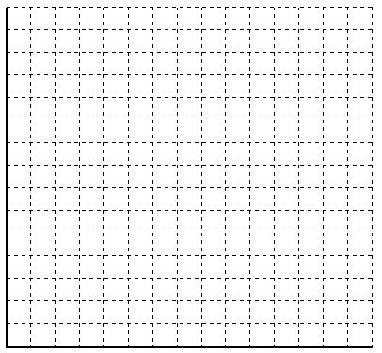

Answer: The center of gravity, weighted by the tonnage at each village cluster, is about 66.8 miles east of Lake Charles and 58.0 miles north of Lake Charles.

Sugar Mill Solution
 | Weighted # trips | x-coord | y-coord | X multiplied | Y multiplied
A | 240. | 90. | 10. | 21,600. | 2,400.
B | 320. | 140. | 60. | 44,800. | 19,200.
C | 450. | 20. | 70. | 9,000. | 31,500.
D | 120. | 50. | 20. | 6,000. | 2,400.
E | 60. | 100. | 80. | 6,000. | 4,800.
F | 140. | 10. | 120. | 1,400. | 16,800.
Total | 1330. | 410. | 360. | 88,800. | 77,100.
Average |  | 68.333 | 60.
Weighted Average |  |  |  | 66.7669 | 57,9699
Median | 665. |  |  | 50. | 60.

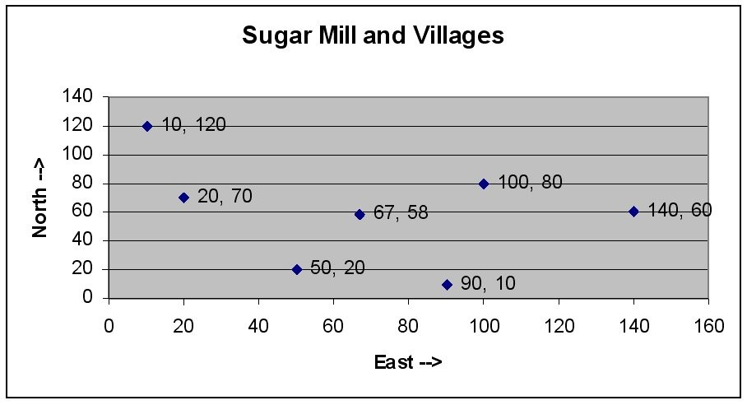
Diff: 2
Topic: Methods of evaluating location alternatives
AACSB: Analytic Skills
Objective: LO8-5

120) A clothing chain is considering two different locations for a new retail outlet. The organization has identified the four factors listed in the following table as the basis for evaluation, and has assigned weights as shown on the right side of this table. The manager has rated each location on each factor, on a 100-point basis (higher scores are better), as shown in the right-hand table.
a. Calculate the composite score for each alternative location.
b. Which site should be chosen?
c. Are you concerned about the sensitivity and subjectivity of this solution? Comment.

Factor | Factor Description | Weight
1 | Average community income | .40
2 | Community growth potential | .25
3 | Availability of public transportation | .15
4 | Labor cost | .20

Barclay | Chester
75 | 70
60 | 80
45 | 90
80 | 60

Answer: The higher rated site is Chester, 74.5 to 67.75. There is a margin of several points, which should overcome most levels of subjectivity. The site factor scores are quite different, so that a small swing in weights could produce swings in scores of a few points, but probably not the seven necessary to reverse the findings.

 | Weight | Barclay | Chester
Factor 1 | 0.40 | 75 | 70
Factor 2 | 0.25 | 60 | 80
Factor 3 | 0.15 | 45 | 90
Factor 4 | 0.20 | 80 | 65
Total | 1.00
Weighted sum |  | 67.75 | 74.5
Weighted average |  | 67.75 | 74.5

Diff: 2
Topic: Methods of evaluating location alternatives
AACSB: Analytic Skills
Objective: LO8-3

121) A manufacturing company is considering two alternative locations for a new facility. The fixed and variable costs for the two locations are found in the table below. For which volume of business would the two locations be equally attractive? If the company plans on producing 50,000 units, which location would be more attractive?

 | Glen Rose | Mesquite
Fixed Costs | $1,000,000 | $1,500,000
Variable Costs ($ per unit) | 25 | 23

Answer: Crossover is at 250,000 units. Below the crossover, Glen Rose must be cheaper as it has the lower fixed cost. Thus, for an estimated unit volume of 50,000, Glen Rose should be chosen.

Break-even points | Units | Dollars
Option 1 vs. Option 2 | 250,000 | 7,250,000
Volume analysis at 50,000 units
 | Option 1 | Option 2
total cost | $2,250,000.00 | $2,650,000.00

Diff: 2
Topic: Methods of evaluating location alternatives
AACSB: Analytic Skills
Objective: LO8-4

122) East Texas Seasonings is preparing to build one processing center to serve its four sources of seasonings. The four source locations are at coordinates shown below. Also, the volume from each source is provided.

a. Calculate the volume-weighted center of gravity.
b. Calculate the simple center of gravity (all cities weighted equally).
c. Explain why the two calculations differ.

 | X-coordinate | Y-coordinate | Volume
Athens, Texas | 30 | 40 | 100
Beaumont, Texas | 20 | 15 | 400
Carthage, Texas | 55 | 60 | 150
Denton, Texas | 20 | 70 | 250

Answer: The weighted center of gravity is located at X = 24,250 / 900 = 26.9, Y = 36,500 / 900 = 40.6. The simple center of gravity is located at X = 125 / 4 = 31.25. Y = 185 / 4 = 46.25. The simple center is more to the east and north than the weighted center of gravity. A partial explanation is that the heaviest tonnage is from Beaumont, which is far to the west and south. Its influence pulls the weighted center toward the west and south.

East Texas Seasonings Solutions
 | Weighted # trips | x-coord | y-coord | X multiplied | Y multiplied
A | 100. | 30. | 40. | 3,000. | 4,000.
B | 400. | 20. | 15. | 8,000. | 6,000.
C | 150. | 55. | 60. | 8,250. | 9,000.
D | 250. | 20. | 70. | 5,000. | 17,500.
Total | 900. | 125. | 185. | 24,250. | 36,500.
Average |  | 31.25 | 46.25
Weighted Average |  |  |  | 26.9444 | 40,5556
Median | 450. |  |  | 20. | 40.

Diff: 2
Topic: Methods of evaluating location alternatives
AACSB: Analytic Skills
Objective: LO8-5

123) Location A would result in annual fixed costs of $300,000 and variable costs of $55 per unit. Annual fixed costs at Location B are $600,000 with variable costs of $32 per unit. Sales volume is estimated to be 30,000 units per year. Which location has the lower cost at this volume? How large is its cost advantage? At what volume are the two facilities equal in cost?
Answer: At 30,000 units, Location A has total costs of $1, 950,000, while Location B has total costs of $1,560,000. Location B is cheaper by $390,000. The crossover occurs where 600,000 + 32X = 300,000 + 55X, or at X = 300,000 / 23 = 13,043 units
Diff: 2
Topic: Methods of evaluating location alternatives
AACSB: Analytic Skills
Objective: LO8-4
124) Using the factor ratings shown below, determine which location alternative should be chosen on the basis of maximum composite score.

 |  | Location
Factor | Weight | A | B | C
Easy access | 0.15 | 86 | 72 | 90
Parking facilities | 0.20 | 72 | 77 | 91
Display area | 0.18 | 86 | 90 | 90
Shopper (walking) traffic | 0.21 | 94 | 86 | 80
Neighborhood wealth | 0.16 | 99 | 89 | 81
Neighborhood safety | 0.10 | 96 | 85 | 75

Answer: A is best (87.96), followed by C (85.16). B is somewhat further behind (83.20).

Factor | Weight | A | B | C
Easy access | 0.15 | 86 | 72 | 90
Parking facilities | 0.20 | 72 | 77 | 91
Display area | 0.18 | 86 | 90 | 90
Shopper (walking) traffic | 0.21 | 94 | 86 | 80
Neighborhood wealth | 0.16 | 99 | 89 | 81
Neighborhood safety | 0.10 | 96 | 85 | 75
Total | 1.00
Weighted sum |  | 87.96 | 83.20 | 85.16
Weighted average |  | 87.96 | 83.20 | 85.16

Diff: 2
Topic: Methods of evaluating location alternatives
AACSB: Analytic Skills
Objective: LO8-3

125) A manager has received an analysis of several cities being considered for a new order fulfillment center (warehouse) for Shop at Home Network. The scores (scale is 10 points = best) are contained in the table below.
a. If the manager weights the factors equally, how would the locations be ranked?
b. If transportation costs and operating costs are given weights that are double the weights of the others, should the locations be ranked differently?

 | Location
Factor | W | X | Y | Z
Business services | 7 | 9 | 5 | 4
Community services | 5 | 7 | 6 | 7
Real estate cost | 7 | 3 | 8 | 6
Construction costs | 8 | 6 | 6 | 5
Operating costs | 5 | 4 | 7 | 6
Business taxes | 6 | 9 | 6 | 4
Transportation costs | 8 | 6 | 7 | 8

Answer: The locations are ranked W, Y, X, Z with equal weights; but W and Y tie for highest, and Z and X tie for lowest as revised.

Factor | Weight | W | X | Y | Z
Business services | 1 | 7 | 9 | 5 | 4
Community services | 1 | 5 | 7 | 6 | 7
Real estate cost | 1 | 7 | 3 | 8 | 6
Construction costs | 1 | 8 | 6 | 6 | 5
Operating costs | 1 | 5 | 4 | 7 | 6
Business taxes | 1 | 6 | 9 | 6 | 4
Transportation costs | 1 | 8 | 6 | 7 | 8
Total | 7 | 46 | 44 | 45 | 40
Weighted average |  | 6.579 | 6.286 | 6.429 | 5.714

 | Weight | W | X | Y | Z
Business services | 1 | 7 | 9 | 5 | 4
Community services | 1 | 5 | 7 | 6 | 7
Real estate cost | 1 | 7 | 3 | 8 | 6
Construction costs | 1 | 8 | 6 | 6 | 5
Operating costs | 2 | 5 | 4 | 7 | 6
Business taxes | 1 | 6 | 9 | 6 | 4
Transportation costs | 2 | 8 | 6 | 7 | 8
Total | 9
Weighted sum |  | 59 | 54 | 59 | 54
Weighted average |  | 6.56 | 6 | 6.56 | 6

Diff: 2
Topic: Methods of evaluating location alternatives
AACSB: Analytic Skills
Objective: LO8-3
126) A telecommunications firm is planning to lay fiber optic cable from several community college distance learning sites to a central studio, in such a way that the miles of cable are minimized. Some locations require more than one set of cables (these are the loads). Where should the studio be located to accomplish the objective?

College | Map Coordinate (x, y) | Load
A | (2,10) | 3
B | (6,8) | 2
C | (4,9) | 4
D | (9,5) | 1
E | (8,1) | 3
F | (3,2) | 2
G | (2,6) | 1

Answer: This is a center-of-gravity problem, even though it is not about shipping tangible items. The center of gravity is at coordinates X = 4.69, Y = 6.25.

 | Weight | X coord | Y coord
Location 1 | 3 | 2 | 10
Location 2 | 2 | 6 | 8
Location 3 | 4 | 4 | 9
Location 4 | 1 | 9 | 5
Location 5 | 3 | 8 | 1
Location 6 | 2 | 3 | 2
Location 7 | 1 | 2 | 6
Sum | 16 | 34 | 41
Average |  | 4.857 | 5.857
Weighted Average |  | 4.6875 | 6.25

Diff: 2
Topic: Methods of evaluating location alternatives
AACSB: Analytic Skills
Objective: LO8-5

127) The owner of a millwork shop is considering three alternative locations for a new plant for building embossed-and-clad steel exterior doors for residences. Fixed and variable costs follow. Since the plant ships nationwide, revenue is assumed the same regardless of plant location. Plot the total cost lines in the chart provided below, and identify the range over which each location is best.

 | Location
Costs | A | B | C
Fixed | $700,000 | $1,000,000 | $1,1000,000
Variable | $28 | $18 | $20

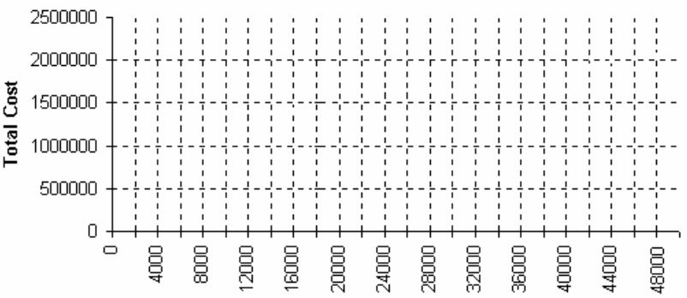

Answer: A is cheapest from 0 to about 30,000 units. B is cheapest thereafter. C can never be preferred.
Break-even points | Units | Dollars
Location A vs. Location B | 30,000 | $1,540,000
Location A vs. Location C | 50,000 | $2,100,000
Location B vs. Location C | -50,000 | $100,000

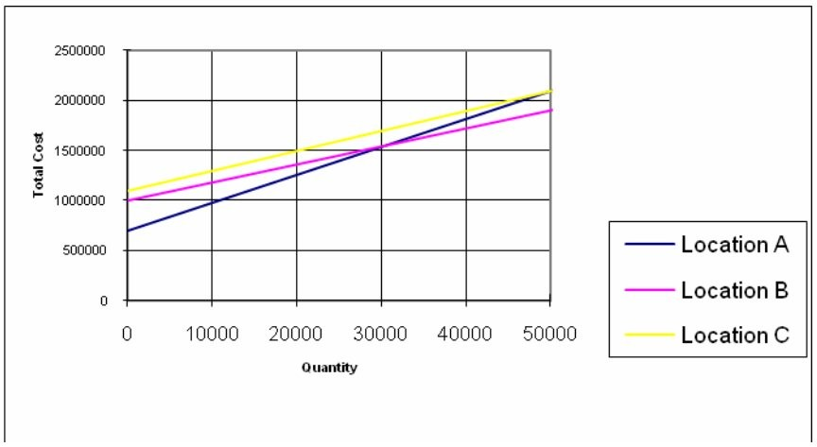
Diff: 2
Topic: Methods of evaluating location alternatives
AACSB: Analytic Skills
Objective: LO8-4
128) A manufacturing firm is considering three potential locations for a new parts manufacturing facility. A consulting firm has assessed three sites based on the four factors supplied by management as critical to the location's success. Given the management-supplied factor weights and the consultant team scores, which location should be selected? Scores are based on 50 = best. Do the results surprise you in any way? Comment.

 |  | Location
Factor | Weight | A | B | C
Labor Climate | 10 | 35 | 45 | 20
Taxes | 30 | 30 | 40 | 40
Utilities | 20 | 25 | 20 | 45
Wages | 40 | 10 | 25 | 25

Answer: C is clearly better than either A or B. This problem illustrates the importance of having good scores on important factors. B has scores that are about as high as those of C, but in the wrong places.

Factor | Weight | A | B | C
Labor Climate | 10 | 35 | 45 | 20
Taxes | 30 | 30 | 40 | 40
Utilities | 20 | 25 | 20 | 45
Wages | 40 | 10 | 25 | 25
Total | 100
Weighted sum |  | 2150 | 3050 | 3300
Weighted average |  | 21.5 | 30.5 | 33.0

Diff: 2
Topic: Methods of evaluating location alternatives
AACSB: Analytic Skills
Objective: LO8-3
129) Environmental Glass Products, Inc. wants to build a new centralized facility to receive household, commercial, and industrial glass for recycling. This center will be supplied by trucks coming from four "collection points," where recyclable glass is dropped off by individuals and businesses. The volume and the map coordinates for the four collection centers are shown below. Where should the collection center be located?

Collection point | Load | (X,Y) Coordinates
A | 9,000 | (4,8)
B | 4,000 | (7,2)
C | 2,000 | (4,1)
D | 5,000 | (7,3)

Answer: The center should be built near coordinates (5.35, 4.85).

Collection Point | Weight | X coord | Y coord
A | 9,000 | 4 | 8
B | 4,000 | 7 | 2
C | 2,000 | 4 | 1
D | 5,000 | 7 | 3
Sum | 20,000 | 22 | 14
Average |  | 5.5 | 3.5
Weighted Average |  | 5.35 | 4.85

Diff: 2
Topic: Methods of evaluating location alternatives
AACSB: Analytic Skills
Objective: LO8-5

130) A manufacturer of stamped metal auto parts has four parts factories in one city at the location coordinates shown below. Each coordinate unit represents a city block (roughly 100 meters). The yearly demand at each factory is also given.

Factories | Demand | X-Coord. | Y-Coord.
Rayburn Industrial Park | 19,000 | 20 | 130
Port of Zavalla | 3,000 | 60 | 40
Henderson Mfg. Center | 5,000 | 70 | 100
Wax Mills Site | 6,000 | 90 | 30

Management has decided to build a new sheet metal mill, to supply these factories, at a location central to these plants. What should be the map coordinates of the new plant? On the grid below, graph the locations of the four parts factories and the proposed sheet metal mill.
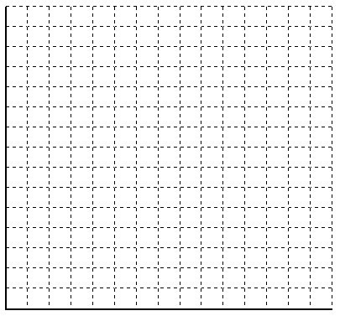
Answer: The mill should be located near (44, 99). The center-of-gravity model does not favor any single data point; it is the weighted average of them all. In this case, being central does not mean being close to any single factory, but it is closer to the collection of all four than any other mill location could be.

Sheet Metal Mill Solution
 | Weighted # trips | x-coord | y-coord | X multiplied | Y multiplied
Rayburn | 19. | 20. | 130. | 380. | 2,470.
Zavalla | 3. | 60. | 40. | 180. | 120.
Henderson | 5. | 70. | 100. | 350. | 500.
Wax MIlls | 6. | 90. | 30. | 540. | 180.
Total | 33. | 240. | 300. | 1,450. | 3,270..
Average |  | 60. | 75.
Weighted Average |  |  |  | 43.9394. | 99.0909.
Median | 17. |  |  | 20. | 130..

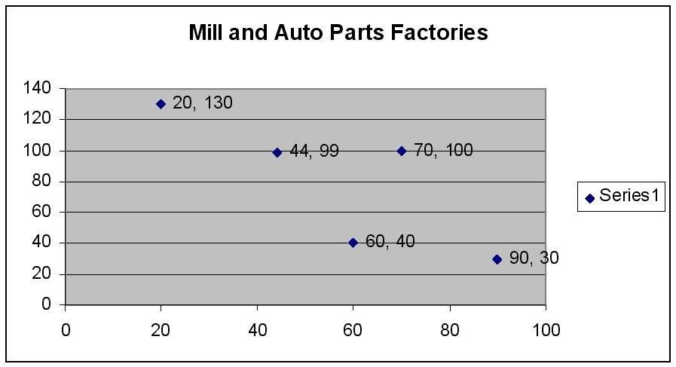
Diff: 2
Topic: Methods of evaluating location alternatives
AACSB: Analytic Skills
Objective: LO8-5

131) A small producer of music boxes wants to move to a larger facility. Two alternative facilities have been found. Site 1 has a fixed cost of $500,000 per year, with a variable cost of $25 per unit. Site 2 has a fixed cost of $800,000 per year, but a variable cost of $22 per unit.
a. Write out the equation for total cost for each site.
b. At what volume of output would the two locations have the same total cost?
c. For what range of output would Site 1 be superior?
d. For what range of output would Site 2 be superior?
Answer: (a) The equation for the total cost at site 1 is TC = 500,000 + 25X, where X is volume. The equation for total cost at Site 2 is TC = 800,000 + 22X. (b) Set these two equations equal and solve for X. 500,000 + 25X = 800,000 + 22X leads to 300,000 = 3X, then to X = 100,000. (c) Site 1 is preferred for volumes up to 100,000 units, and (d) site 2 is preferred above 100,000 units.
Diff: 2
Topic: Methods of evaluating location alternatives
AACSB: Analytic Skills
Objective: LO8-4
132) A small manufacturer is considering several locations for a new facility. They have identified four factors that they consider to be important for their location decision. They have decided to assign scores to the four factors, with a higher score indicating a more favorable location. Use the information in the following table to perform a factor rating to select the best location.

 | Weight | Location A | Location B | Location C
Wages | 40 | 30 | 75 | 90
Labor Climate | 30 | 40 | 70 | 40
Taxes | 15 | 80 | 40 | 90
Utilities | 15 | 75 | 60 | 10

Answer: Location B is the preferred location.

 | Weight | Location A | Location B | Location C
Wages | 40 | 30 | 75 | 90
Labor Climate | 30 | 40 | 70 | 40
Taxes | 15 | 80 | 40 | 90
Utilities | 15 | 75 | 60 | 10
Total | 100
Weighted sum |  | 4725 | 6600 | 6300
Weighted average |  | 47.25 | 66 | 63

Diff: 2
Topic: Methods of evaluating location alternatives
AACSB: Analytic Skills
Objective: LO8-3
133) A contractor for the military is looking for a new location for a supply depot. The depot will supply four bases whose tonnage (demand) and map coordinates are shown below. If management wants the depot to have a central location, what should be its map coordinates?

Bases | (X,Y) Coordinates | Tonnage
Fort Able | (40,110) | 30,000
Base Baker | (70,50) | 60,000
Camp Charlie | (90,20) | 35,000
Camp Delta | (70,80) | 75,000

Answer: The depot should be located near X = 69, Y = 65.

Bases | Weight | X coord | Y coord | X mult. | Y mult.
Fort Able | 30,000 | 40 | 110 | 1,200,000 | 3,300,000
Base Baker | 60,000 | 70 | 50 | 4,200,000 | 3,000,000
Camp Charlie | 35,000 | 90 | 20 | 3,150,000 | 700,000
Camp Delta | 75,000 | 70 | 80 | 5,250,000 | 6,000,000
Sum | 200,000 | 270 | 260 | 13,800,000 | 13,000,000
Weighted Average |  |  |  | 69 | 65

Diff: 2
Topic: Methods of evaluating location alternatives
AACSB: Analytic Skills
Objective: LO8-5

134) A highway contractor needs to locate a single supply point to provide road building materials to four projects. The four projects, which are all approximately the same magnitude, are located at the following coordinates. Coordinate units are in miles.

 | X (East) | Y (North)
Project A | 50 | 10
Project B | 15 | 60
Project C | 40 | 60
Project D | 30 | 20

a. On the grid below, plot the locations of the four road-building sites. Properly label all points.
b. What is the center of gravity?
c. If a single truck were sent from center-of-gravity to each project and back (four round trips), how many miles would be traveled? (Hint: use the Pythagorean Theorem C = 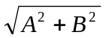).
d. Add the calculated center of gravity to the grid.

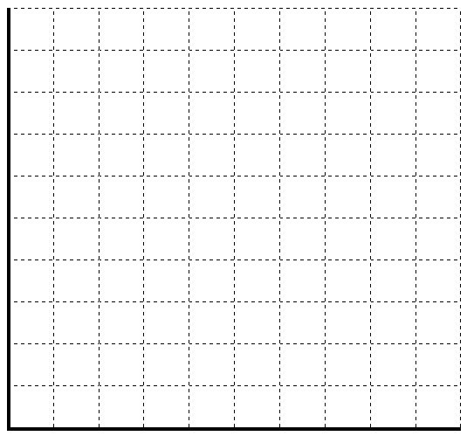
Answer:
a. Coordinates are (50, 10), (15, 60), (40,60), and (30, 20)
b. The supply point should be at (33.75, 37.50).

 | Weight | X coord | Y coord
Project A | 1 | 50 | 10
Project B | 1 | 15 | 60
Project C | 1 | 40 | 60
Project D | 1 | 30 | 20
Sum | 4 | 135 | 150
Average |  | 33.75 | 37.5
Weighted Average |  | 33.75 | 37.5

c.
 | Distance to COG
Project A | 31.94
Project B | 29.29
Project C | 23.35
Project D | 17.90

31.94*2 + 29.29*2 + 23.35*2 + 17.9*2 = 204.96 total miles traveled
d. Coordinates are (33.75, 37.50
Diff: 3
Topic: Methods of evaluating location alternatives
AACSB: Analytic Skills
Objective: LO8-5
135) Every month, a distribution center will deliver 14,000 units to Retailer A at coordinates (20, 10), 12,000 units, to Retailer B at coordinates (30, -15), and 20,000 units to Retailer C at coordinates (4, 4). Assuming no constraints on location, at what coordinates should the distribution center be located (rounded to two decimal places)?
Answer: (15.65, 0.87), where 15.65 = [20(14) + 30(12) + 4(20)]/(14 + 12 + 20), and 0.87 = [10(14) - 15(12) + 4(20)]/(14 + 12 + 20).
Diff: 2
Topic: Methods of evaluating location alternatives
AACSB: Analytic Skills
Objective: LO8-5

136) A school district is considering where in town to house its central office (The office must also be located at an existing school for cost reasons). If there are five schools in the district, with locations and size given in the following table, use the COG method to determine at which school the central office should be placed to minimize the average distance between the office and students.

Location | X,Y | Size (Enrollment)
A | 5,5 | 2500
B | 0,5 | 1000
C | 0,0 | 10000
D | 5,0 | 4500
E | 2,1 | 7500

Answer: The total number of students is (2500+1000+10000+4500+7500)=25500
X=(5*2500+0*1000+0*10000+5*4500+2*7500)/25500 = 1.96
Y=(5*2500+5*1000+0*10000+0*4500+1*7500)/25500= .98
Rounding these gives (X,Y) of (2,1) which is closest to school E.
Diff: 2
Topic: Methods of evaluating location alternatives
AACSB: Analytic Skills
Objective: LO8-5
137) A school district is considering four locations for a new high school. There are four factors the district is considering (Cost of land, distance to students, land size, and traffic flow). The district would like to compare results using two weighting systems. The first system would give each factor equal weight and the second would give the factors weights of .4, .2, .1, and .3 respectively. Fill in the missing information in the table and then use the factor rating method to determine which location is best for each weighting system.

Factor | W(1) | W(2) | A | B | C | D
Cost of Land | 1 | .4 | 10 | 20 | 25 | 5
Distance to Students | 1 | .2 | 30 | 25 | 15 | 20
Land Size | 1 | .1 | 5 | 10 | 20 | 40
Traffic Flow | 1 | .3 | 20 | 5 | 15 | 30

Answer: Students should first fill in the W(1) and W(2) columns as shown (note W(1) can have any value so long as each value is equal). Applying the factor rating method gives the following results:

Site | W(1) | W(2)
A | 65 | 16.5
B | 60 | 15.5
C | 75 | 19.5
D | 95 | 19

Thus the district should select site D under W(1) and site C under W(2). Note that site D scores similarly to site C under W(2) and thus other factors (such as politics) could make site D an acceptable choice.
Diff: 2
Topic: Methods of evaluating location alternatives
AACSB: Analytic Skills
Objective: LO8-3

138) A manufacturing company is considering three expansion options. The first is to do nothing (Option A). The next is to leave the current plant open and also open a new larger plant (Option B). Finally they could close the existing plant and open the new, larger one (Option C). Given the VC and FC from the table below calculate the range for which each option minimizes cost.

Option | FC ($) | VC ($/unit)
A | 50000 | 2
B | 100000 | 1
C | 60000 | 1.4

Answer: Attached is the graph of the total cost with respect to units produced.

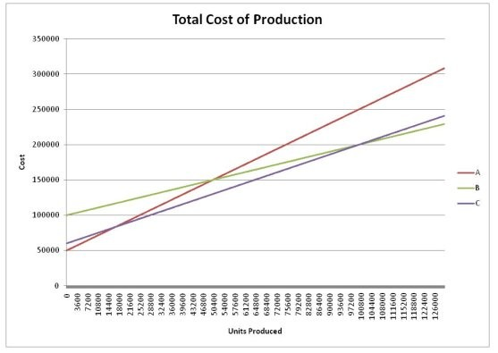

To solve for the crossover points students should set the total cost functions equal for the various options. This gives the following equations
50000+2x=100000+x, x=50000 units
50000+2x=60000+1.4x, x=16667 units
100000+x=60000+1.4x, x=100000 units
To check which function is the lowest cost for a given range students should test each function for its total cost. For example
A(0)=50000+2(0)=50000
B(0)=100000+1(0)=100000
C(0)=60000+1.4(0)=60000
Therefore for the range 0 to 16667 option A is cheapest.
A( 20000)=90000
B(20000)= 120000
C(20000)=88000
Therefore for the range 16667 to 50000 option C is cheapest.
A(60000)=170000
B(60000)=160000
C(60000)=144000
Therefore for the range 50000 to 100000 option C is cheapest
A(110000)=270000
B(110000)=210000
C(110000)=214000
Therefore for the range 100000 or more option B is cheapest

Combining these ranges shows that for production of under 16667 units A is cheapest, for between 16667 and 100000 C is cheapest, and for 100000 and above B is cheapest.
Diff: 2
Topic: Methods of evaluating location alternatives
AACSB: Analytic Skills
Objective: LO8-4

139) A grocery chain is deciding on where to locate its new distribution center. The new DC will serve four grocery stores, each with a demand of 10,000 units. If the coordinates of the stores are (112,108), (110,50), (40, 85), and (10, 25) where should the DC be located? Suppose now that each store instead had demand of 20,000 units. Where should the DC go in this case?
Answer: Since each store has the same demand the x and y coordinates can simply be averaged and the DC will be located in the same spot for each case.
X=(112+110+40+10)/4 =68
Y=(108+50+85+25)=67
Thus the DC should be located at (68,67) for both cases.
Diff: 2
Topic: Methods of evaluating location alternatives
AACSB: Analytic Skills
Objective: LO8-5

140) Suppose that a bus company is deciding where to locate its central hub. There are 6 possible destinations for the buses. Suppose that the center of town will be used as the reference for describing the possible destinations. A is located 5 miles South and 3 miles West. B is located 3 miles North and 2 miles East. C is located 1 mile South and 5 miles East. D is located 2 miles North and 3 miles West. E is located exactly in the center of town. F is located 10 miles North and 5 miles East. Assume that traffic to each destination will be equal. Where should the hub go so that travel time is minimized?
Answer: Since each site has the same demand the coordinates can simply be averaged. Converting the center of town to (0,0) will mean that coordinates that are labeled South become —y and those labeled West become —x, while North becomes +y and East +x. Thus the location is found to be:
X= (-3+2+5-3+0+5)/6 =1
Y= (-5+3-1+2+0+10)/6=1.5
Converting back into direction yields 1 mile East and 1.5 miles North of the center of town should be the location for the hub.
Diff: 2
Topic: Methods of evaluating location alternatives
AACSB: Analytic Skills
Objective: LO8-5

